# DSE Capstone Project

horizontal line

**Project Summary**

|  |  |
| --- | --- |
| Batch details | PGPDSE-BLR Oct22 |
| Team members | Venkata Sai Pavan Teja Angina  Akhil Anilkumar  Shivaprasad G  Sahil Kumar Meher  Arun Sv |
| Domain of Project | Retail |
| Proposed project title | Telecom Customer Churn |
| Group Number | 9 |
| Team Leader | Sahil Kumar Meher |
| Mentor Name | Mrs.Pranita Mahajan |

Date: 19 February 2023

Sahil Kumar Meher

Signature of the Mentor Signature of the Team Leader

Page **1** of **15**

# Table of Contents

|  |  |  |
| --- | --- | --- |
| Sl. No. | Topic | Page No |
| 1 | Overview | 3 |
| 2 | Business problem  goals | 3 |
| 3 | Topic survey in brief | 6 |
| 4 | Critical assessment of  topic survey | 10 |
| 5 | Methodology to be  followed | 10 |
| 6 | References | 14 |

**Overview**

The telecommunications sector has become one of the main industries in developed countries. The technical progress and the increasing number of operators have raised the level of competition. Companies are working hard to survive in this competitive market depending on multiple strategies.

Customer churn is a considerable concern in service sectors with highly competitive services. On the other hand, predicting the customers who are likely to leave the company will represent potentially large additional revenue source if it is done in the early phase.

# Business problem statement

## Business Problem Understanding

Customer churn is a major problem and one of the most important concerns for large companies. Due to the direct effect on the revenue of the companies, especially in the telecom field, companies are seeking to develop means to predict potential customer to churn. Therefore, finding factors that increase customer churn is important to take necessary actions to reduce this churn.

## Business Objective

The main contribution of our work is to develop a churn prediction model which assists telecom operators to predict customers who are most likely to subject to churn.

## Scope of the project

The scope of our project is comparative analysis of different ML models and classification of customers and predict whoare likely to churn from the available data and recommending the services to each customers so as to retain them and development of revenue model.

## Approach

Data analysis, cleaning/pre-processing: The pre-processing of the dataset before performing ML functions involves the following:

* 1. **Descriptive Analysis:** Descriptive Analysis is used to describe the basic features of the data in a study. It provides summary of the data and the type of columns. Measures of variability help communicate the spread of distribution by describing the shape and spread of the data set.
  2. **Treatment of Missing Values**: Detecting and handling missing values is important, as they can impact the results of the analysis, and there are algorithms that can’t handle them. There are cases when a variable has a lot of missing values. In that case, we can drop the variable. For the categorical variable, the missing values can be replaced by the most frequent class of the variable. For the numeric variable, missing values can be replaced by the mean/ median.
  3. **Treating Outliers:** Outlier is an observation in the data that lies at an abnormal distance from other values. Presence of Outliers, may result in inaccurate prediction. Hence it is necessary to remove them. The interquartile range is one of the measures of outlier treatment. It is the difference between the third quartile and the first quartile. The IQR gives the range of middle 50% of the data which is free from outliers.

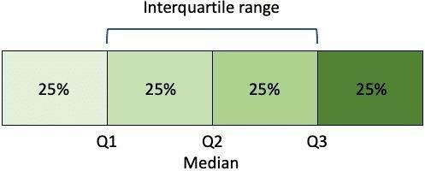

IQR = Q3 - Q1

* 1. **Encoding Categorical Variables**: Since, machine learning models are based on Mathematical equations and we can intuitively understand that it would cause some problem if we can either keep the Categorical data by encoding the categorical variable or we can drop by checking whether we need the variable for further modelling process because we would only want numbers in the equations.
  2. **Dropping Unnecessary Columns**: We are removing the columns which do not contribute to the model building or the columns which are of less, or of no importance
  3. **Removal / Replacing of Special Characters (if any):** Special characters such as ‘?’, ‘$’, ‘%’ should be replaced with Nan so that they are easier to treat and replace or to remove.
  4. **Scaling**: It helps to normalize the data within a particular range and as well as in speeding up the calculations in an algorithm.

# Topic Survey in brief

## Problem understanding

The reason behind describing customer churn in the preceding paragraphs is because, the goal of our next Machine Learning project is to develop an algorithm that can accurately predict customers who are most likely to churn. With the help of various visualization libraries that are at our disposal, we will be able to figure out possible parameters that govern a customer’s decision to churn.

## Current solution to the problem

Customer retention is extremely critical to the health of any business, regardless of size or industry. It is a common representation of a business’s ability to keep its existing customers and maximize its revenue. It is important to dig into the factors that drive your customer retention rate and generate opportunities to improve your customer success strategy.

Current solution for customer churn:

* + Competitive Pricing.
  + Classification of customers.
  + Service recommendation to each customers.
  + Offer incentives.
  + Frequent Feedback from Customers.
  + Seamless customer service.
  + Wide network coverage.
  + Exclusive benefits for existing customers.
  + Analyze churn when it happens.

## Proposed solution to the problem

Exploratory Data analysis, Data Visualization, Building ML Models using different Algorithms to drive predictive analysis.

## Decision Tree Algorithm:

Decision Tree is the most powerful and popular tool for classification and prediction. A Decision tree is a flowchart-like tree structure, where each internal node denotes a test on an attribute,

each branch represents an outcome of the test, and each leaf node (terminal node) holds a class label. Types of Decision Trees

1. Categorical Variable Decision Tree
2. Continuous Variable Decision Tree

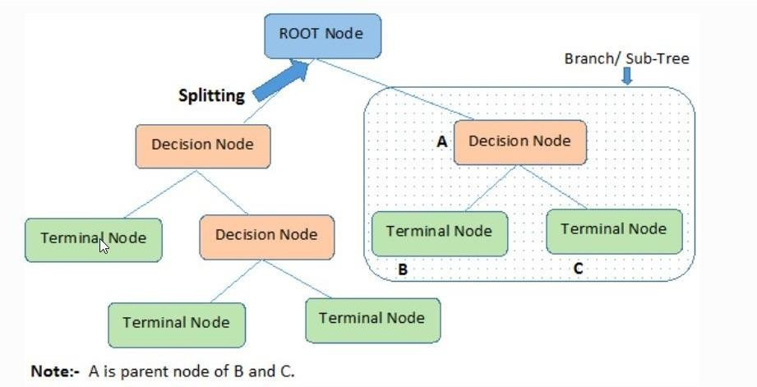

## Random Forest

Random Forest is an ensemble technique capable of performing both regression and classification tasks with the use of multiple decision trees and a technique called Bootstrap and Aggregation, commonly known as bagging. The basic idea behind this is to combine multiple decision trees in determining the final output rather than relying on individual decision trees.

Random Forest has multiple decision trees as base learning models. We randomly perform row sampling and feature sampling from the dataset forming sample datasets for every model. This part is called Bootstrap.

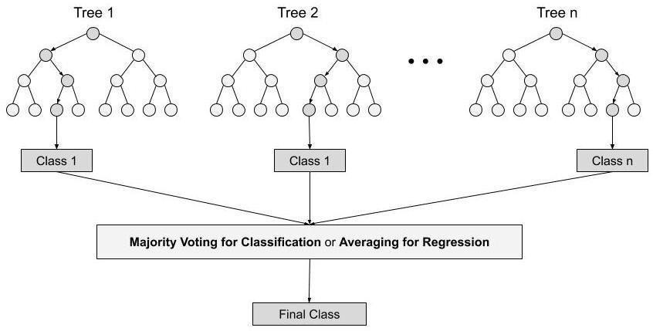





## Logistic Regression

Logistic regression is a transformation of a linear regression using the sigmoid function. The vertical axis stands for the probability for a given classification and the horizontal axis is the value of x. It assumes that the distribution of Bernoulli distribution. The formula of LR is as follows:

Here 𝛽_0+𝛽_1 𝑥 is similar to the linear model y = ax + b. The logistic function applies a sigmoid

𝐹**(**𝑥**)=1/ (1+** 𝑒**^ (−(**𝛽**_0+**𝛽**_1** 𝑥**)))**

function to restrict the y value from a large scale to within the range 0–1.

Logistic regression is a process of modeling the probability of a discrete outcome given an input variable. The most common logistic regression models a binary outcome; something that can take two values such as true/false, yes/no, and so on. Multinomial logistic regression can model scenarios where there are more than two possible discrete outcomes. Logistic regression is a useful analysis method for classification problems, where you are trying to determine if a new sample fits best into a category. As aspects of Retail and Marketing classification problems -Customer Churn, such logistic regression is a useful analytic technique.

Predictive models built using this approach can make a positive difference in your business or organization. Because these models help you understand relationships and predict outcomes, you can act to improve decision-making.

## Gradient Boosting

Gradient boosting algorithm is one of the most powerful algorithms in the field of machine learning. As we know that the errors in machine learning algorithms are broadly classified into two categories i.e. Bias Error and Variance Error. As gradient boosting is one of the boosting algorithms it is used to minimize bias error of the model.

Unlike, Ada boosting algorithm, the base estimator in the gradient boosting algorithm cannot be mentioned by us. The base estimator for the Gradient Boost algorithm is fixed and i.e. Decision Stump. Like, AdaBoost, we can tune the n_estimator of the gradient boosting algorithm. However, if we do not mention the value of n_estimator, the default value of n_estimator for this algorithm is 100.

Gradient boosting algorithm can be used for predicting not only continuous target variable

(as a Regressor) but also categorical target variable (as a Classifier). When itis used as a regressor, the cost function is Mean Square Error (MSE) and when it is used as a classifier then the cost function is Log loss. We want our predictions, such that our loss function (MSE) is minimum.

## Critical Assessment of Topic Survey

Once the customers at risk of churning have been identified, the **customer retention team** has to know exactly what marketing action to run. The reasons for churning out differs from person to person. Hence, it is critical to practice ‘targeted proactive retention’. This means knowing in advance which marketing action will be the most effective for each and every customer.

## Methodology to be followed

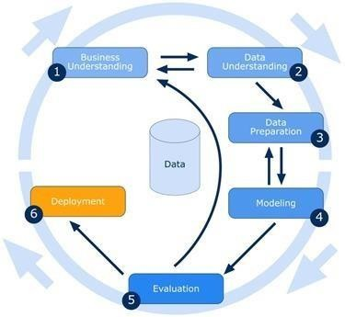

### Business Understanding:

It’s all about understanding the overview, the aspects of business activities & the necessary problems which the business is facing.

### Data understanding:

It involves study of data, shape, datatypes, number of rows and columns, type of columns and categories them into numerical and categorical data.

### Data preparation:

This involves Preprocessing of Data

* Access the data
* Ingest (or fetch) the data
* Cleanse the data
* Format the data
* Combine the data
* And finally Analyze the data
  + - **Variable information:**

|  |  |
| --- | --- |
| **Variable Name** | **Variable Description** |
| Customer ID | Primary key of the record. |
| Churn | Information about Churn of the Customers. |
| Monthly Revenue | Revenue of each Customer |
| Monthly Minutes | Number of Minutes call spoken by Customer |
| Total Recurring Charge | The Charges for the Service |
| Director Assisted Calls | When we call an operator to request a telephone number |
| Overage Minutes | Count of Call used over duration to particular post-paid cell  phone plan |
| Roaming Calls | The ability to get access to the Internet when away from home at the price of a local call or at a charge considerably  less than the regular long-distance charges. |
| Three way Calls | A way of adding a third party to your conversation without  the assistance of a telephone operator. |
| Dropped Calls | Count of Phone calls gets disconnected somehow from the  cellular network. |
| Blocked Calls | Count of Telephone call that is unable to connect to an  intended recipient. |
| Unanswered Calls | Count of Calling that an individual perceives but is not  currently pursuing. |

|  |  |
| --- | --- |
| **Variable Name** | **Variable Description** |
| Received Calls | Number of calls received by the customer. |
| Out bound Calls | Call initiated by the call centre agent to customer on behalf of  client to know the target customer behaviour and needs. |
| Inbound Calls | In inbound calls, call-centre or customer-care receives call  from customer with issues and questions. |
| Peak Calls In Out | Amount of time period with fewer calls than are handled in a  busy period. |
| Call Forwarding Calls | Count of Calls Forwarded by user. |
| Dropped Blocked Calls | Number of VM messages customer currently has on the server. |
| Call Waiting Calls | Duration of call-in waiting period |
| Months In Service | Number of months customer using service. |
| Unique Subs | subscription of different networks |
| Active Subs | subscriptions of the networks that are active or in usage. |
| Service Area | Network service area |
| Handset Models | Count of Handsets are used to Contact one to one. |

|  |  |
| --- | --- |
| Age HH1 | User aged below 45 |
| Age HH2 | User aged above 45 |
| Children in HH | Whether there are Children in House hold |
| Handset Refurbished | Are the handsets refurbished or not |
| Handset Web Capable | Are the handsets capable of internet connectivity |
| Truck Owner | Is the user a Truck Owner |
| RV Owner | Is the user an RV owner |
| Home Ownership | Is the house the user is staying, his own |
| Buys Visa Mail Order | Does the user buy Visa Mail order |
| Responds to Mail Offers | Does the user respond to Mail offers |
| Opt-out Mailings | Did he opt out of the mail offers sent to him |

|  |  |
| --- | --- |
| Non-US-Travel | Does the user travel to other countries |
| Owns-Computer | Does he have a computer or not |
| Has-Credit Card | Does he have a credit card or not |
| Retention Calls | No of Retention Calls |
| Retention Offers Accepted | Customers accepting retaining the retaining offers given by the company. |
| New Cell phone User | Number of customers buying new cell phone. |
| Referrals Made By Subscriber | Referrals made by the existing customer to the other customer. |
| Income Group | The column talks about the customer saying to which category the customer belongs to. |
| Owns Motorcycle | The columns ask about the customer weather the customer owns a motorcycle or not. |
| Adjustments To Credit Rating | Rating Scale |
| Handset Price | Its amount paid by the customer for his cell phone. |

## Modeling

Based on the observation of Descriptive & Inferential Statistic & recognizing the right model.

## Evaluation

Uses some metric or combination of metrics to "measure" objective performance of model. Test the model against previously unseen data.

## Deployment

Applying the Data to the model

## Reference:

* + Customer Churn Analysis in Telecom Industry Dataset :- https:/[/www.kaggle.com/datasets/jpacse/datase](http://www.kaggle.com/datasets/jpacse/datasets-for-churn-telecom)t[s-for-churn-telecom](http://www.kaggle.com/datasets/jpacse/datasets-for-churn-telecom)
  + Customer Churn Analysis

Brief Overview of Customer Churn Analysis and Prediction with Decision Tree Classifier. Retrieved from [https://towardsdatascience.com/customer-churn-analysis-](https://towardsdatascience.com/customer-churn-analysis-4f77cc70b3bd)

[4f77cc70b3bd](https://towardsdatascience.com/customer-churn-analysis-4f77cc70b3bd)

* + Customer churn analysis: Churn determinants and mediation effects of partial defection in the Korean mobile telecommunications service industry (2006). Retrieved from <http://people.stern.nyu.edu/shan2/customerchurn.pdf>
  + Teemu Mutanen.Customer churn analysis – a case study.

Retrieved from [https://citeseerx.ist.psu.edu/viewdoc/download?doi=10.1.1.103.7169&rep=rep1&type](https://citeseerx.ist.psu.edu/viewdoc/download?doi=10.1.1.103.7169&rep=rep1&type=pdf)

[=pdf](https://citeseerx.ist.psu.edu/viewdoc/download?doi=10.1.1.103.7169&rep=rep1&type=pdf)

* + Churn Analysis: 3-Step Guide to Analyzing Customer Churn Dominique Jackson(March 31, 2020).

Retrieved from <https://baremetrics.com/blog/churn-analysis>

* + Customer Churn Analysis: A Comprehensive Guide Amit Phaujdar on ChurnAnalysis, Marketing Analytics (March 15th, 2021).

Retrieved from <https://hevodata.com/learn/understanding-customer-churn-analysis/>

* + Understanding Random Forest

How the Algorithm Works and Why it Is So Effective.

Retrieved from [https://towardsdatascience.com/understanding-random-forest-](https://towardsdatascience.com/understanding-random-forest-58381e0602d2) [58381e0602d2](https://towardsdatascience.com/understanding-random-forest-58381e0602d2)

* + Logistic Regression.

Retrieved from <https://www.sciencedirect.com/topics/computer-science/logistic-regression>

* + Decision Tree Algorithm, explained.

Retrieved from [https://www.kdnuggets.com/2020/01/decision-tree-algorithm-](https://www.kdnuggets.com/2020/01/decision-tree-algorithm-explained.html) [explained.html](https://www.kdnuggets.com/2020/01/decision-tree-algorithm-explained.html)

* + Prashant Gupta : Decision Trees in Machine Learning(May 18, 2017).

Retrieved from [https://towardsdatascience.com/decision-trees-in-machine-learning-](https://towardsdatascience.com/decision-trees-in-machine-learning-641b9c4e8052) [641b9c4e8052](https://towardsdatascience.com/decision-trees-in-machine-learning-641b9c4e8052)

* + Logistic regression.

Retrieved from <https://www.ibm.com/topics/logistic-regression>

* + Gradient Boosting from scratch.

Retrieved from [https://blog.mlreview.com/gradient-boosting-from-scratch-](https://blog.mlreview.com/gradient-boosting-from-scratch-1e317ae4587d) [1e317ae4587d](https://blog.mlreview.com/gradient-boosting-from-scratch-1e317ae4587d)

## Notes For Project Team

|  |  |
| --- | --- |
| Original owner of data | PAMINA |
| Data set information | The Data Contains information about Telecom Company |
| Any past relevant articles using the dataset | NA |
| Reference | Telecom Churn (Cell to Cell) |
| Link to web page | https[://www.](http://www.kaggle.com/datasets/jpacse/datasets-for-)kag[gle.com/datasets/jpacse/datasets-for-](http://www.kaggle.com/datasets/jpacse/datasets-for-) churn-telecom |

***********************************************************